User Guide

TrustCall-X ADMIN CONSOLE

ACCESS AND LOGIN

Admin Console URL: https://<backend-ip>/Account/Login

**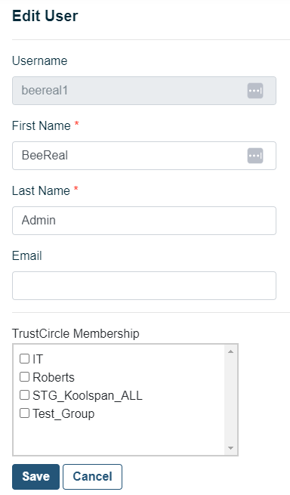

Username: **administrator**

Temporary Password: **<TempPWD> from KoolSpan**

At the initial login, the administrator will change the password though the RESET funcion.

Additional Administrators may be created after the first login (ref. “New User” option in this document)

By default, after the login, the Administrator is taken to the USER PAGE, populated by all the TrustCall user accounts present in the system. The user list can be either:

* automatically Imported from an existing AD: the administrator can refer to the installation guide that shows how to connect and configure the TrustCall backend with the AD. In this case, the users will be visualized in the Admin Console in read-only mode. To enable the editing options, the AD connection must be disabled after the first import..
* Or manually imported and managed by the Administrator, who can edit. delete or even create additional users.

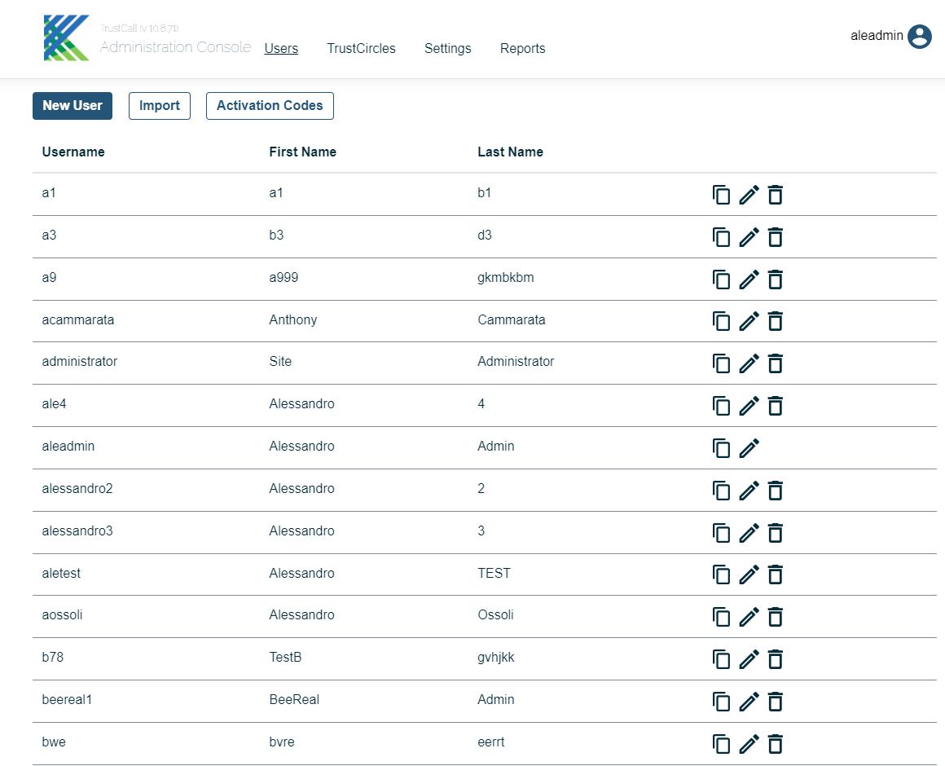

Edit / View user details, including the device activation status

Delete the user

Option to copy the activation code into the admin’s clipboard

USER PAGE

SSAGES and GROUP CHAT

After selecting a specific contact or group, access the chat page to start or continue an end-to-end secure conversation. Within the same session, a user may also share a file or initiate a call

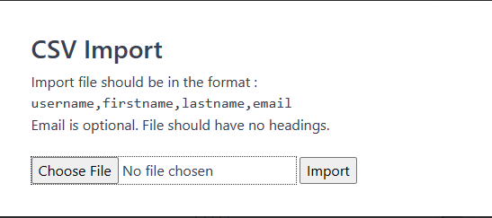

This procedure manually creates a new user account. The Administrator supplies:

* Username (unique and non-modifiable)
* First Name
* Last Name
* Email (optional)
* The admin then associates the user with one of the existing TrustCircles

This option imports users in bulk from an external CSV file formatted in the following way

After the import, the admin will associate users with one of the existing TrustCircles

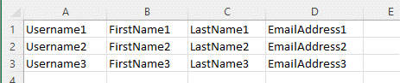

This option allows the Administrator to export all the users’ activation codes in bulk. An external CSV file is generated

This sections shows the system configurations that were applied duing the system installation and configuration process (ref. TCX instruction guides)

The only admin-editable field is the “TrustDomain”, that represents the URL the user must insert in the mobile and desktop APPs during the LOGIN process

SETTINGS

SSAGES and GROUP CHAT

After selecting a specific contact or group, access the chat page to start or continue an end-to-end secure conversation. Within the same session, a user may also share a file or initiate a call

The Administrator associates each user to one or more TrustCircles. This allows a flexible tightening of communication channels between users. Each user’s contact list in the APP will be populated by those contacts sharing at least one TrustCircle. The TrustCircles can also be used to pre-define admin-managed conference rooms in TrustCall APP.

TRUST CIRCLES

SSAGES and GROUP CHAT

After selecting a specific contact or group, access the chat page to start or continue an end-to-end secure conversation. Within the same session, a user may also share a file or initiate a call

When the AD integration is enabled, the TrustCircle configuration is inherited from the AD itself and all the editing options are disabled. If the Administrator needs to modify the configuration of TrustCircles for users imported from AD, the AD integration must be disabled after the import. Please refer to the Instruction Guide to enable/disable AD integration

Deletion of the TrustCircle. The existing members will be disassociated

The Administrator creates a new TrustCircle by specifying the name and selecting the members

The Administrator visualizes and modifies the name and the members of an existingTrustCircle

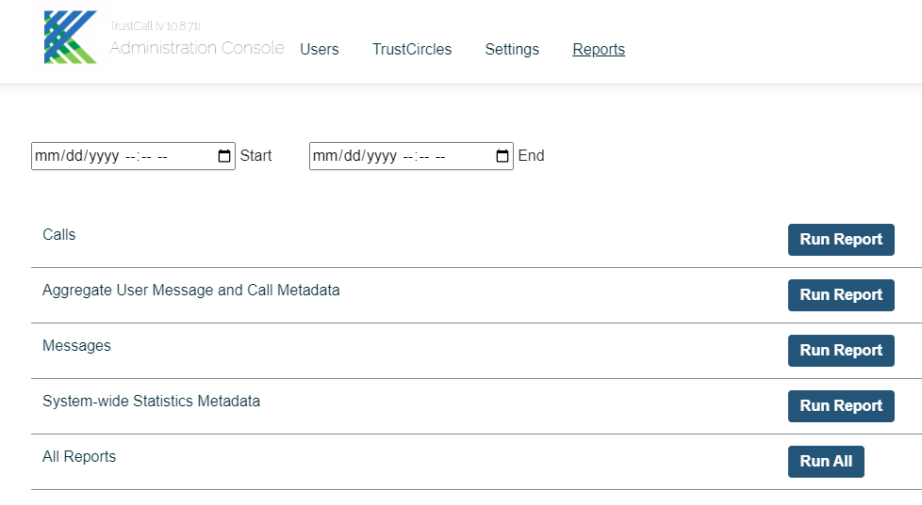

REPORTS

The Administrator generates and exports service metadata, statistics and service reports

1. Calls Metadata within a period of time (date, time, duration, caller, called person/people, answered Y/N)
2. User’s aggregated statistics for messages and calls
3. Call and Message metadata per user
4. Global System Statistics
5. Generates all the reports and bundles them together

Select Speaker